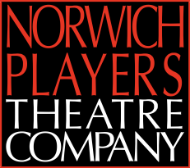
The Norwich Players Theatre Company
Audition Submission Form
Please complete this form if you would like to audition and email it as an attachment to : steven.scase@maddermarket.org
* Due to legal requirements we are unable to cast actors who are under 18 on the day of Audition.
Name
Email Address
Phone Number
Gender Identity and Pronouns
Playing Age This is not your actual age. Please mark all the boxes that apply.  * You must be over 18 at audition. | * 16-20 | 20-30 | 30-40 | 40-55 | 55-65 | 65 +
Production auditioning for | MURDER IN THE STUDIO
Part or parts auditioning for See the production’s casting breakdown for options.
Preferred Audition dates
See the production’s casting breakdown for options - Please state ‘any’ if you have no preference.
Days/Evenings of the week or Dates you are NOT available for rehearsals between now and the end of the performances.
Please read the statement below before signing and dating this document.
I understand that my data will be processed in accordance with
the General Data Protection Regulation (GDPR) as described below.
Signature
This can just be typed
Date
The Maddermarket Theatre Trust Ltd is committed to ensuring the security and protection of your personal information. Information provided above will be shared only with relevant personnel as deemed necessary and will be stored/disposed of securely in line with data protection principles, according to the General Data Protection Regulation (GDPR). Personal details gathered via this form will not be used by the Norwich Players Theatre Company for marketing purposes.
Charity number 234993 | Company reg number 00355871 | VAT number 105910010

