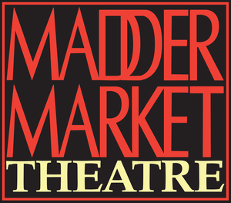

Help us to save the Maddermarket Theatre! We need your support!

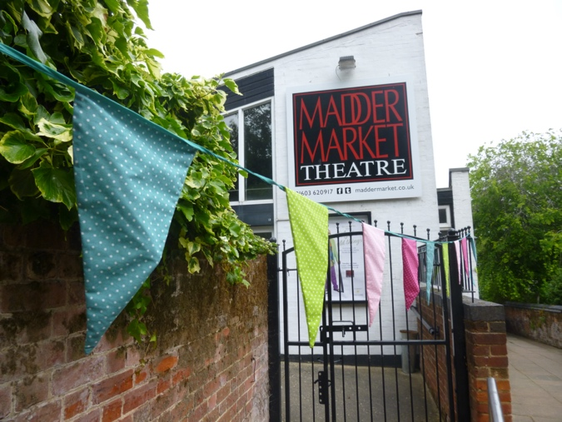

Norwich’s Community Theatre

The Maddermarket Theatre Trust Ltd. is a registered charity in the UK. As a charitable arts organisation in the heart of Norwich, we are committed to supporting community engagement through affordable performing arts, entertainment and events. The Maddermarket Theatre receives no regular public funding and therefore we rely on the support of our audiences and friends, through the tickets you buy and the donations you make. Please consider organising a fundraising event for us or perhaps taking on a personal challenge, such as a 5k/10k walk/jog/run, a marathon, a sponsored head shave…a sponsored performance!

Maddermarket Patron, Arthur Smith, says:

“I am pleased to support the charming Maddermarket Theatre, where I spent many nights in my student days. It is one of Norwich’s best venues, has a long history of great shows and is ready to be revitalised to create new exciting theatre for everyone”

Fundraising Toolkit
This fundraising toolkit should help you to organise an event or personal challenge to raise vital funds for the Maddermarket Theatre Trust

Sponsorship
Once you’ve planned your fundraising event or challenge, set up an online sponsorship page and send the link to everyone you know. All your donations will automatically come to The Maddermarket Theatre Trust Ltd. And be sure to share your sponsorship page on Facebook, Twitter, LinkedIn and all your social media channels.
You can also use a paper sponsorship form to keep with you for opportune moments and to collect donations from people in person.
1. Ask people to sponsor you using the form below. Or, set up an online sponsorship form at www.virginmoneygiving.com or www.justgiving.com
2. Remind your sponsors that The Maddermarket Theatre Trust Ltd can claim Gift Aid if they are a UK taxpayer.
3. Send completed forms back to Sue Bergin, The Maddermarket Theatre, St John’s Alley, Norwich NR2 1DR. You can pay the sponsorship money via our donate page - https://maddermarket.co.uk/donate/
4. Download additional sponsorship forms at https://maddermarket.co.uk/support-us/

Every donation helps The Maddermarket Theatre Trust to continue to be at the heart of the community, rebuild our infrastructure and also make vital repairs to our old and increasingly tired building. We have to raise a minimum of £135,000 per year just to keep our doors open.

Ask your friends, family and colleagues to sponsor you. Everything you collect helps us support Norwich’s community theatre.

Sponsor’s full name (required) | Full home address including post code (required) | Gift Aid * | £ | Date  (dd/mm/yy)

*If I have ticked the box headed ‘Gift Aid’, I confirm that I am a UK taxpayer. I have read this statement and want The Maddermarket Theatre Trust to reclaim tax on my donation, given on the date shown. I understand that if I pay less Income Tax/or Capital Gains tax in the current tax year than the amount of Gift Aid claimed on all of my donations it is my responsibility to pay any difference. I understand that The Maddermarket Theatre Trust will reclaim 25p of tax on every £1 that I have given. The Maddermarket Theatre Trust will use this information only for Gift purposes; we will not use this information for marketing or share it with any third parties other than HMRC. Registered Charity Number 234993. Company reg number 00355871. VAT number 105910010.

Other Ways to Fundraise

There are lots of fantastic ways to support the Maddermarket Theatre. Here are a few ideas:

Raise £s by organising a coffee morning.

Raise £s by selling unwanted items on eBay or by having a car boot sale.

Raise £s by organising a pub quiz. Charge each person £5 to enter. Recruit eight teams of six people and have a competition or raffle on the night to boost the amount raised.

Raise £s – book the Maddermarket Theatre for your fundraising event. Simply email fundraising@maddermarket.org

Raise £s by organising a mini festival. Have a DJ, glitter station and food. Charge people for entrance and promote the event in local media.

You can get collecting buckets from the theatre.

